**VELAMMAL BODHI CAMPUS**

**GRAND TEST - IV**

**CLASS: X MARKS: 80**

**SUBJECT: SCIENCE (BATCH-I) DURATION: 3Hrs**

**General Instructions:**

i. This question paper consists of 39 questions in 5 sections

ii. All questions are compulsory however and internal choices is provided in some questions a students are expected to attend only one of these questions

iii. Section A consist of 20 objective type questions carrying 1 mark each

iv. Section B consists of 6 VERY SHORT questions carrying 02 mark each. Answer these questions should be in the range of 30 to 50 words.

v. Section C consists of 7 SHORT questions carrying 03 marks each. Answer to these questions should be in the range of 50 to 80 words.

vi. Section D consists of 3 LONG Answer questions carrying 05 mark each. Answer to these questions should be in the range of 80 to 120 words.

vii. Section E consists of 3 SOURCE/CASE Based units of assessment of 04 marks each with sub parts.

**SECTION - A**

1. A boy records that 4000 J of work is required to transfer 10 C of charge between two points of a resistor of 50 Ω. The current passing through it is,

(a) 16 A (b) 4 A (c) 2A (d) 8 A

2. Which of the following statement is incorrect?

(a) The bending of ray of light on passing from different medium to one medium is called reflection.

(b) The phenomenon of splitting of white light into seven constituent colours is known as the disperson of light.

(c) Refractive index of medium depends upon its temperature.

(d) Refractive index is directly proportional to the optical density of the medium.

3. Which among the following statements is incorrect for magnesium metal?

(a) It burns in oxygen with a dazzling white flame. (b) It reacts with cold water to form magnesium oxide and evolves hydrogen gas. (c) It reacts with hot water to form magnesium hydroxide and evolves hydrogen gas. (d) It reacts with steam to form magnesium hydroxide and evolves hydrogen gas.

4. Consider the following table:

|  |  |
| --- | --- |
| Substance | pH |
| Lemon | 2.3 |
| Battery acid | x |
| Sea water | 8.5 |
| Apple | 3.1 |

The value of x in above table is:

(a) 0 (b) 7.3 (c) 12.5 (d) 6.9

5. The reaction 2Na + Cl2 2NaCl is an example of (a) combination reaction (b) decomposition reaction (c) displacement reaction (d) double displacement reaction

6. Which among the following is (are) double displacement reaction(s)? 1) Pb + CuCl2 PbCl2 + Cu 2) Na2 SO4 + BaCl2  BaSO4 + 2NaCl 3) C+O2 CO2 4) CH4 + 2O2 CO2 + 2H2O (a) 1 and 4 (b) Only 2 (c) 1 and 2 (d) 3 and 4

7. What is the balanced chemical equation?

(a) The atom of each element is different before and after chemical reaction. (b) The atoms and elements are equal in chemical reactions (c) The no. of atoms of all elements are equal after the chemical reaction. (d) The number of atoms of each element remains the same, before and after chemical reaction

8. The reaction that differs from the rest of the reaction given is- (a) formation of calcium oxide from limestone (b) formation of aluminium from aluminium oxide (c) formation of sodium carbonate from sodium hydrogen carbonate (d) formation of mercury from mercuric oxide

9. Which of the following statements is true for acids? (a) Bitter and change red litmus to blue (b) Sour and change red litmus to blue (c) Sour and change blue litmus to red (d) Bitter and change blue litmus to red

10. The length of small intestine in a deer is more as compared to the length of small intestine of a tiger. The reason for this is:

(a) Mode of intake of food (b) Type of food consumed (c) Presence or absence of villi in intestines

(d) Presence or absence of digestive enzymes.

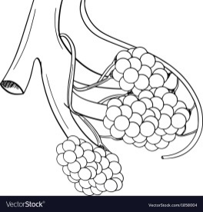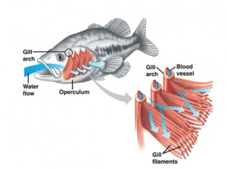11. Respiratory structures of two different animals – a fish and a human being are as shown. Observe both and select one characteristic that hold true for both of them.

(a) Both are placed internally in the body of animal.

(b) Both have thin and moist surface for gaseous exchange

(c) Both are poorly supplied with blood vessels to conserve energy.

(d) In both the blood returns to the heart after being oxygenated.

12. Characters that are transmitted from parents to offspring during reproduction show

(a) only similarities with parents (b) only variations with parents

(c) both similarities and variations with parents (d) neither similarities nor variations

13. Which is the correct sequence of the components of a reflex arc?

(a) Receptors→ Muscles→ Sensory neuron→ Motor neuron→ Spinal cord

(b) Receptors→ Motor neuron → Spinal cord → Sensory neuron → Muscle

(c) Receptors → Spinal cord → Sensory neuron → Motor neuron → Muscle

(d) Receptors → Sensory neuron → Spinal cord → Motor neuron → Muscle

14. Which statement shows the interaction of an abiotic component with a biotic component in an ecosystem?

(a) A grasshopper feeding on a leaf (b) Rainwater running down into the lake

(c) An earthworm making a burrow in the soil (d) A mouse fighting with another mouse for food

15. Which of the following is an example of genetic variation?

(a) One person has a scar, but his friend doesn’t (b) One person is older than the other

(c) Reeta eats meat, but her sister Geeta is a vegetarian (d) Two children have different eye colour

16. In the below figure, parts A, B and C are, sequentially,

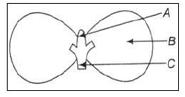

(a) Cotyledon, plumule and radicle (b) Plumule, radicle and cotyledon

(c) Plumule, cotyledon and radicle (d) Radicle, cotyledon and plumule

**Assertion – Reasoning based questions. These consist of two statements -Assertion (A) and Reason (R). Answer these questions selecting the appropriate option given below: (a) Both ‘A’ and ‘R’ are true and ‘R’ is correct explanation of the Assertion (b) Both ‘A’ and ‘R’ are true but ‘R’ is not correct explanation of the Assertion. (c) ‘A’ is true but ‘R’ is false. (d) ‘A’ is false but ‘R’ is true.**

17. **Assertion:** In a conductor, free electrons keep on moving but no magnetic force acts on a conductor in a magnetic field.

**Reason:** Force on free electrons due to magnetic field always acts perpendicular to its direction of motion.

18. **Assertion (A):** Brown fumes are produced when lead nitrate is heated. **Reason (R):** Nitrogen di oxide gas is produced as a by- product due to the decomposition of lead nitrate.

19. **Assertion:** A geneticist crossed a pea plant having violet flowers with a pea plant with white flowers.

He got all violet flowers in first generation.

**Reason:** White color gene is not passed on to next generation.

20. **Assertion:** Condoms serve the role of mechanical barrier in pregnancies.

**Reason:** The copper – T is placed in the uterus to prevent ovulation.

**SECTION - B**

21. i) Explain why the refractive index of any material with respect to air is always greater 1.

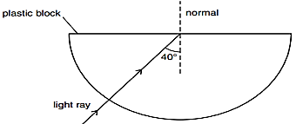ii) In the given figure a light ray travels from air into the semi-circular plastic block. Give a reason why the ray does not deviate at the semi-circular boundary of the plastic block

**OR**

A ray of light is incident at an angle of 45° at the interface of medium (1) and medium (2) as shown in the diagram. Redraw this diagram and complete it. If the angle of refraction is 30° find the refractive index of medium (2) with respect to medium (1).

(Given that sin 45 $°$ = 1/ √2 and sin 30 = 1/2)

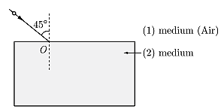

22. What is the percentage of power dissipated if the current I through a resistor is increased by 100% assume that temperature remains constant.

23. A metal **A**, which is used in thermit process, when heated with oxygen gives an oxide **B**, which is amphoteric in nature. Identify **A** and **B**. Write down a balanced chemical equation for the reaction between oxide **B** and NaOH.

**OR**

In one method of rust prevention, the iron is coated with another element. Name the method and define it.

24. a. Why do all the gametes formed in human female have X chromosome?

b. Give the pair of contrasting traits of the following characters in pea plant and mention which is

dominant and recessive

(1) Yellow seed (2) Round seed

25. What is clone? Why do offspring formed by asexual reproduction exhibit remarkable similarity?

26. a. Construct a terrestrial food chain comprising four trophic levels.

b. Calculate the amount of energy available to the organisms at the fourth trophic level if the energy available to the organisms at the second trophic level is 2000 J.

**SECTION – C**

27. a) Ravi kept a book at a distance of 10 cm from the eyes of his friend Hari. Hari is not able to read anything written on the book. Explain why?

b) A lens of focal length 5.0 cm is being used by a student in the laboratory as a magnifying glass. His least distance of distinct vision is 25 cm. What magnification is the student getting?

28. i) What is the meaning of electric power of an electrical device? Write its S.I. unit.

ii) An electric kettle of 2 kW is used for 2h. Calculate the energy consumed in

a) kilowatt hour and b) joules.

29. i) What is the function of earth wire in electrical instruments?

ii) Explain what is short circuiting an electric supply.

iii) What is the usual current rating of the fuse wire in the line to feed

a) Lights and fans? b) Appliances of 2kW or more power?

**OR**

a) Which effect of the electric current is utilised in the working of an electrical fuse?

b) Is a fuse connected in series or in parallel in household circuit?

c) How many times does AC used in India change direction in one second?

30. An ore on treatment with dil. HCl gives the smell of rotten eggs. Name the type of this ore. Write the chemical equations involved to obtain the metal from its concentrated ore

31. (a) A non-metal **X** exists in two different forms **Y** and **Z**. Y is the hardest natural substance whereas **Z** is a good conductor of electricity. Identify **X**, **Y**, **Z**.

(b) An element **X** on reaction with oxygen forms an oxide **X**O2. The oxide when dissolved in water turns blue litmus red. State whether element X is a metal or non metal. Identify that element. (c) Name the metal which is alloyed with copper to make bronze

32. (a) What are the advantages of reflex actions that are governed by spinal cord?

(b) Why is chemical communication better than electrical impulses as means of communication between cells in a multi cellular organism?

33. (a) Bile juice does not have any digestive enzyme but still plays a significant role in the process of digestion. Justify the statement.

(b) List out any two differences between blood and lymph

**OR**

(a) In the process of respiration, state the function of alveoli.

(b) Rate of breathing in aquatic organisms is much faster than in terrestrial organisms. Give reasons

(c) Write the pathway showing the breakdown of glucose in the presence of oxygen.

**SECTION – D**

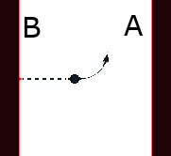34. a) You are sitting in a chamber with your back to B wall. An electron beam moving horizontally from wall B towards wall A. It is deflected by a strong magnetic field to your left side. What is direction of the magnetic field?

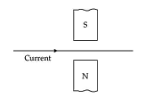b) In which direction, does the wire shown in the diagram tend to move?

c) With the help of a diagram of experimental setup, describe an activity to show that the force acting on a current carrying conductor placed in a magnetic field increases with increase in field strength.

35. (a) Write the molecular formula of an organic compound having its name suffixed with ‘ ol ’ and having two carbon atoms in the molecule. With the help of balanced chemical equation indicate what happens when it is heated with excess of concentrated H2 SO4.

(b)Write names of the following compounds:

(i) HCOOH (ii) CH3COCH2CH3.

(c)Explain with two valid reasons why carbon generally forms compounds by covalent bonds and not by ionic bonds.

**OR**

(a)Define catenation. Explain why no other element exhibits the properties of catenation to the extent seen in carbon compounds? Name one another element that exhibits this property of catenation other than carbon. (b)Name the compound formed by the reaction of an organic acid and an alcohol. Write the chemical equation for the reaction involved

36. (A) A green stemmed rose plant denoted by GG and a brown stemmed rose plant denoted by gg are allowed to undergo a cross with each other.  
(a) List your observations regarding :

(i) Colour of stem in their F1 progeny?   
(ii) Percentage of brown stemmed plants in F2 progeny if F1 plants are self pollinated.  
(iii) Ratio of GG and Gg in the F2 progeny.  
(b) Based on the findings of this cross, what conclusion can be drawn?

**OR**

(B) (i) Draw a diagram showing germination of pollen on stigma of a flower and mark the following parts – (i) Pollen grain (ii) Pollen tube (iii) Stigma (iv) Female germ cell.

(ii) Is fertilization possible without pollination? If yes/No justify your answer.

(iii) State the significance of pollen tube.

(iv) Name the parts of flower that develop after fertilization into Seed and Fruit.

**SECTION – E**

37. While dealing with the reflection of light by spherical mirrors, we shall follow a set of sign conventions called the New Cartesian Sign Convention. In this convention, the pole (P) of the mirror is taken as the origin. The principal axis of the mirror is take as the x -axis of the coordinate system. In a spherical mirror, the distance of the object from its pole is called the object distance (u). The distance of the image from the pole of the mirror is called the image distance (v). Magnification produced by a spherical mirror gives the relative extent to which the image of an object is magnified with respect to the object size. It is expressed as the ratio of the height of the image to the height of the object. It is usually represented by the letter (m).

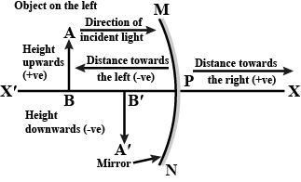

i) How can you calculate the magnification of a spherical mirror?

ii) What does a negative sign in the value of magnification indicates?

iii) Find the focal length of a convex mirror whose radius of curvature is 32 cm.

**OR**

iv) Why does the height of the object is taken to be positive?

38. Read the following and answer the questions:

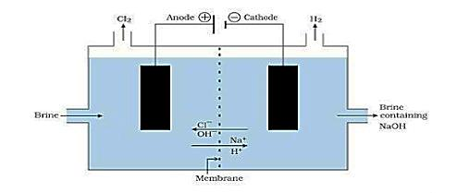

**‘A neutralization reaction’** is a reaction where an acid and a base react to form water and a salt. The familiar example of salt is sodium chloride which we use in our food on daily basis. It is prepared by the reaction of hydrochloric acid and sodium hydroxide solution. This salt is used to prepare various compounds. When electricity is passed through an aqueous solution of sodium chloride (called brine), it decomposes to form sodium hydroxide, chlorine gas and hydrogen gas.

A metal carbonate **X** on heating with acid gives a gas which when passed through a solution **Y** gives the metal carbonate **X** back. On the other hand, a gas **G** that is obtained at anode during electrolysis of brine is passed on dry **Y**, it gives a compound **Z**, used for disinfecting drinking water.

(i) Identify **X**, **Y**, **G** and **Z**.

(ii)What is the nature of the gas that evolves when **X** is heated?

(iii) Write the reaction involved in the formation of **G**?

**OR**

(iii) Write the reaction involved when **G** reacts with **Y**.

39. Some plants like the pea plant climb up other plants or fences by means of tendrils. These tendrils are sensitive to touch. When they come in contact with any support, the part of the tendril in contact with the object does not grow as rapidly as the part of the tendril away from the object. This causes the tendril to circle around the object and thus cling to it. More commonly, plants respond to stimuli slowly by growing in a particular direction. Because this growth is directional, it appears as if the plant is moving.

i) How many type of tropism are shown by plants? Name them.

ii) The touch me not plant is an example of which tropism?

iii) Give one example of chemotropism?

iv) Name the plant hormone which promotes cell division and inhibits growth.